4/26/2019 Report

By William Kerr

Here’s what I did for the past week.

I contacted MorningStar via email. They told me what library they use for their program.

I found out pymodbus is a piece of shit. Sometimes it works, sometimes it doesn’t.

I wrote 2 modular libraries to extract information from the Tristar MorningStar MPPT using 2 different libraries: pymodbus, and modbus-tk. Modbus-tk is more reliable, but more power-consuming.

Pymodbus is less power-consuming, but less reliable. MinimalModbus is too small for our application.

My computer crashed, so I had to import my data to a new computer, and rewrite my code to scan all ports for a port that works. Example:

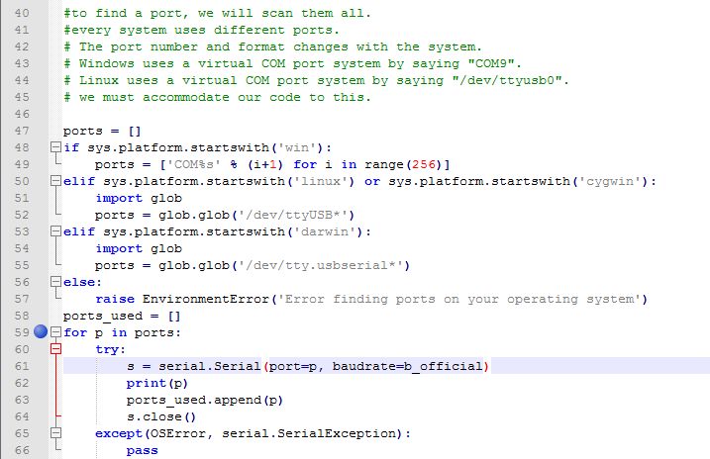

I wrote a BMS library, too. I tried testing it in the Greenhouse, but it doesn’t work. I think the BMS system doesn’t have power at all (the batteries are probably dead), and that’s why it won’t read.

The EMUS BMS company also has its own reading software. It didn’t work, either. That reinforces my suspicion that the BMS system doesn’t have power. I need permission to remove the main hub from the battery network, and plug in my own hardware I purchased from EMUS. I would like to connect it to a 12V DC power source (the lab benches in BE 310 should have that.)

I probed the Tristar Morningstar MPPT transmitting pin, and it seems to be transmitting at 9600baud.